ASR Selection Analysis
Benchmarking Speech Recognition for a Blue-Collar Hiring Platform

The recommendation summary
For capturing where a candidate lives on a phone or WhatsApp voice note, Deepgram Nova-3 is the right default (85% locality accuracy), with Whisper large-v3 (80%) as the open-source fallback when cost or data-residency rules out an API.
The most important finding is uncomfortable: if you had picked a model by its published WER, you would have picked the wrong one. The model with the best clean-data WER (IndicConformer, 5.5% on Kathbath) lands fourth on the task that actually matters. WER and entity accuracy disagree — and for this product, only entity accuracy is something that matters more.

1. The task, and why I changed the metric
The platform doesn't need a perfect transcript. It needs one fact per call: the locality the candidate names as it is something important for a hiring platform. A transcript can be 30% wrong word-for-word and still be useful if it nails "Koramangala" — and a low-WER transcript that does not recognise it is useless.
So I made entity accuracy (did the locality survive, matched fuzzily against the 20 known localities) the primary metric, with WER/CER as secondary diagnostics. I also tracked mean entity distance on misses — how badly a model fails — because a near-miss ("core mangala") is recoverable by fuzzy-matching, while a total miss is not.

2. Models and why each one is here
Five systems, chosen to span the real decision axes — paid API vs open, multilingual vs Hindi-only, large vs fast.
Model | Type | Coverage | Why it's in the test
Deepgram Nova-3 | Paid API | Multilingual (Indic) | Mandated baseline; Vahan's reported prod ASR
Sarvam Saarika v2.5 | Paid API | India-focused, Kannada | The "built for India" challenger
Whisper large-v3 | Open | Multilingual | The default everyone reaches for
IndicConformer-600M | Open | 22 Indian langs | Strong published Indic numbers; WER champion
IndicWav2Vec | Open | Hindi-only | The "fast and cheap" extreme
In one line: APIs cost money but need no ops; open models are free but you carry the GPU; Hindi-only models are fast but blind to Kannada and English; large multilingual models are slower but robust.

3. Datasets and method
- Primary — 20 self-recorded clips of Bangalore localities, spoken as a candidate would on a call. Deliberately varied across condition (quiet, noisy, phone call recording, rushed, whispered) and language (Hindi, Hinglish, Kannada, English) so I could slice failures, not just average them.
- Secondary — 20 Common Voice Hindi + 20 Kathbath Hindi clips, to compare against clean published-style benchmarks and expose the WER.
- Each clip run through all 5 models; ground truth from ground_truth.csv; identical scoring code across models.
One bug worth confessing, because it's also a production lesson. Hindi/Kannada models return native script; my first scoring pass compared Devanagari against Roman references and unfairly scored them ~0. I added a transliteration-to-Roman layer before matching. In production you need exactly this layer to match ASR output against a Roman locality database — and it's lossy on English terms ("layout" → लेआउट → "leaaut"), itself a source of error.

4. Headline results

Locality accuracy on the real task (self-recordings)
Model | Entity acc. | WER | CER | Median latency
Deepgram Nova-3 | 0.85 | 0.74 | 0.21 | 1.49 s
Whisper large-v3 | 0.80 | 0.87 | 0.30 | 1.16 s
Sarvam Saarika | 0.75 | 0.83 | 0.29 | 0.63 s
IndicConformer | 0.70 | 0.99 | 0.39 | 1.27 s
IndicWav2Vec | 0.35 | 1.10 | 0.46 | 0.03 s

WER is high across the board because the references are Romanized conversational sentences. Read the entity column, not the WER column.

The same models on clean Hindi benchmarks
Model | Common Voice WER | Kathbath WER
Sarvam Saarika | 0.14 | 0.089
Deepgram Nova-3 | 0.19 | 0.21
IndicConformer | 0.20 | 0.055
IndicWav2Vec | 0.21 | 0.12
Whisper large-v3 | 0.26 | 0.17

The insight that surprised me

1)The two rankings invert. On Kathbath, IndicConformer (0.055) beats Deepgram (0.21) by ~4x on WER — yet on the actual locality task Deepgram (0.85) beats IndicConformer (0.70). Sarvam tops the clean WER charts but sits third on entities. A team that selected from a leaderboard would have shipped IndicConformer or Sarvam and quietly lost ~15 points of locality accuracy. Clean read-speech benchmarks do not predict noisy entity-capture performance. You have to test on your own task.
2) The Kannada High Accuracy (don't over-claim). Deepgram scored 3/3 on Kannada clips — but Nova-3's Indic set does not officially include Kannada. On three short clips it almost certainly caught the locality phonetically. I am not claiming Deepgram supports Kannada; the sample is too small and support isn't documented but this tells the ability of Deepgram to catch the meaning

5. Failure analysis — where they break
I sliced the 20 × 5 = 100 self-recording runs by condition and by language (pooled across models).
By condition — phone audio is the killer : noisy street/traffic 0.84, quiet 0.73, whispered 0.70, rushed 0.67, and phone call just 0.45.

By language — Hinglish is the universal weak spot. Pooled accuracy: Kannada 1.00, Hindi 0.80, English 0.70, Hinglish (code-switch) just 0.50.
Code-switching ("Bellandur lake ke side mein") trips every model — they commit to one language and butcher the other half. Since candidates do speak Hinglish, this is the single biggest accuracy lever.

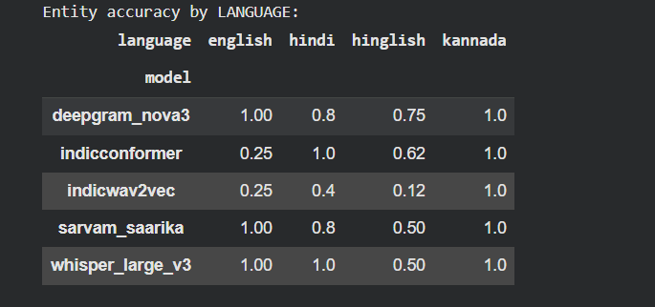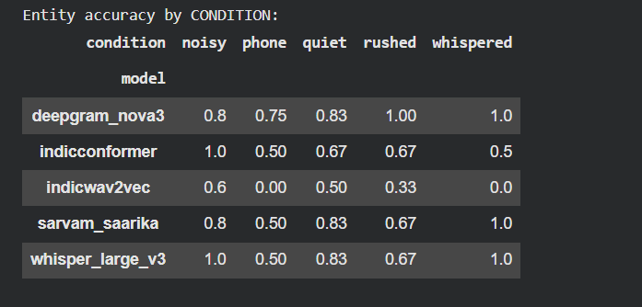

6. Beyond accuracy

RTF = (time to transcribe) / (duration of the clip). It's the unit-free way to ask "can this model keep up with live audio?" RTF below 1.0 means the model transcribes faster than real time (a 5-second clip processed in under 5 seconds); above 1.0 means it falls behind and a queue builds up. For a phone IVR where the candidate is waiting on the line, you want RTF comfortably under 1.0

Mean entity distance on misses : when a model fails to capture the locality, this measures how close it got (0 = perfect, 1 = totally wrong). A model that misses with "Koramangla" (distance ~0.1) is recoverable — you fuzzy-match it against your known-localities list. A model that outputs "Karnataka" (distance ~0.8) is silently, dangerously wrong. Two models with identical entity accuracy can score very differently here

And Despite the relative RTF of Deepgram and Whisper is high but their less number of misses and entity distance is what makes them preferable for use

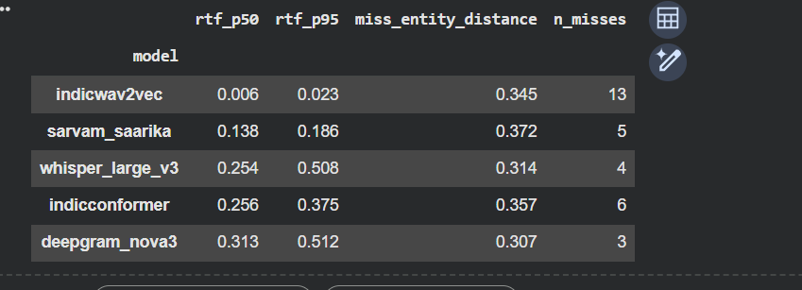

7. Recommendation
Constraint | Pick | Rationale
Default (accuracy first) | Deepgram Nova-3 | Best locality accuracy (0.85), no ops, matches prod
Cost / data-residency forces open | Whisper large-v3 | Closest accuracy (0.80), free per-call

And regardless of model, do three things:
- Add a fuzzy-match layer against the known locality list — most failures are near-misses worth ~10+ points of recovered accuracy.
- Prioritize Hinglish and phone-channel robustness — the two worst slices and exactly the production input. Consider fine-tuning or a code-switch-aware decoder here.

8. Honest limitations
- n = 20 self-recordings (3–4 per condition slice), 2-3 speaker and Kannada conclusions in particular rest on just 3 clips.
- High WER on self-recordings is partly an artifact of Romanized references vs native-script output — which is why I lead with entity accuracy.
- Latency measured on Colab T4, not a production endpoint; absolute numbers will differ from those that are actually in use at large scale.

